**Domino Square**

These are the 'double-3 down' dominoes.

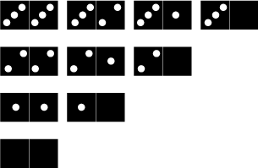

Use these dominoes to make this square so that each side has eight dots.

